**CENWP-OD-B28 August 2023**

**MEMORANDUM FOR THE RECORD**

**SUBJECT: 23BON085 MFR Cascades Island LPS RB4 Pacific Lamprey Mortality**

On the morning of 28 August, Project Biologists discovered one adult Pacific Lamprey mortality in the Cascades Island LPS Rest Box 4 (CI LPS RB4). The fish was scanned for PIT tags, inspected, and returned to the river.

1. Species – Pacific Lamprey (*Entosphenus tridentatus)*
2. Origin – Unknown
3. Length – 57.2 cm
4. Marks and tags – None
5. Marks and Injuries found on carcass – None
6. Cause and Time of Death – Unknown
7. Future and Preventative Measures – None

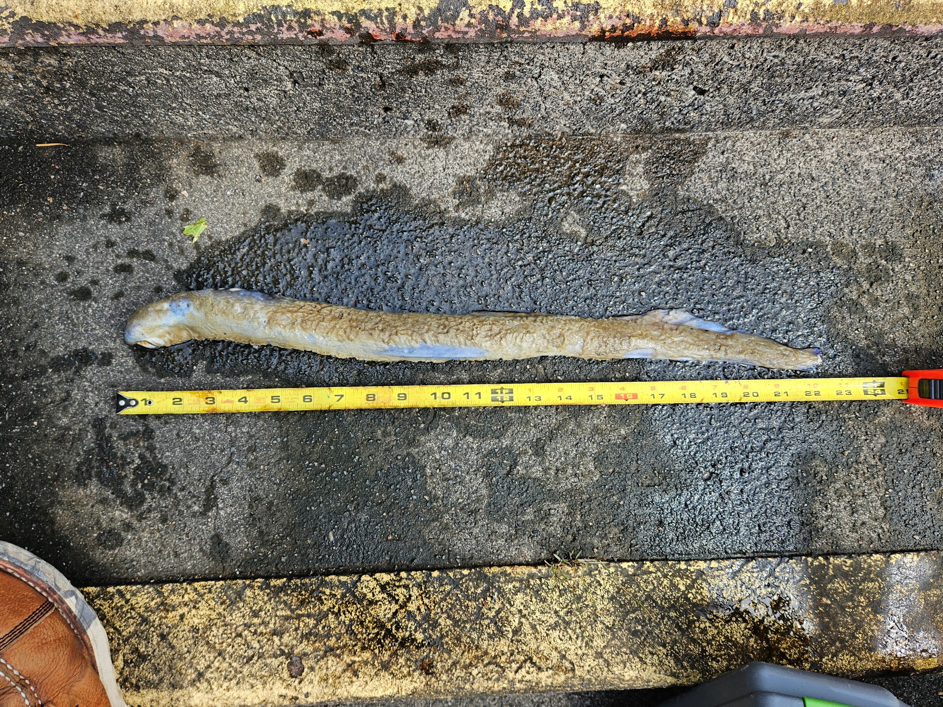

Sincerely,

BON Project Fisheries